Mock Api’s Assignment

# API no 1:

**“Get”-**Api:

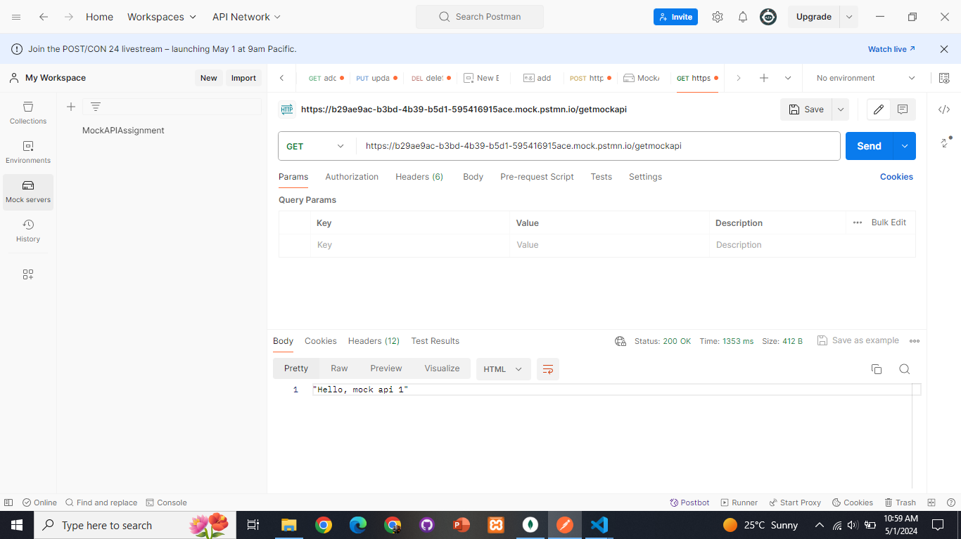

# API no 2:

**“POST”-**Api:

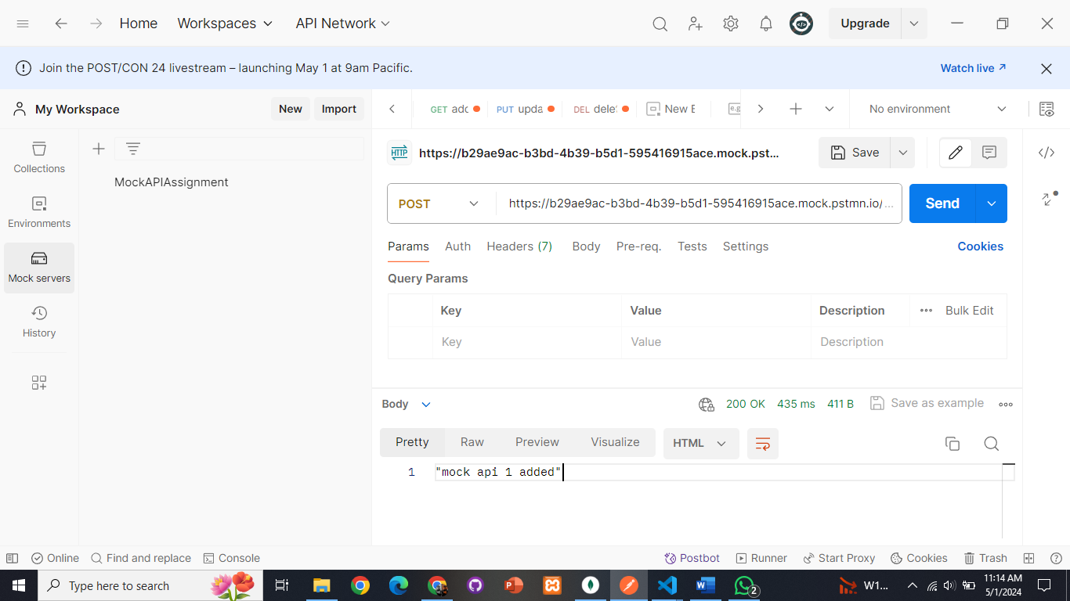

# API no 3:

**“PUT”-**Api:

# API no 4:

**“DELETE”-**Api:

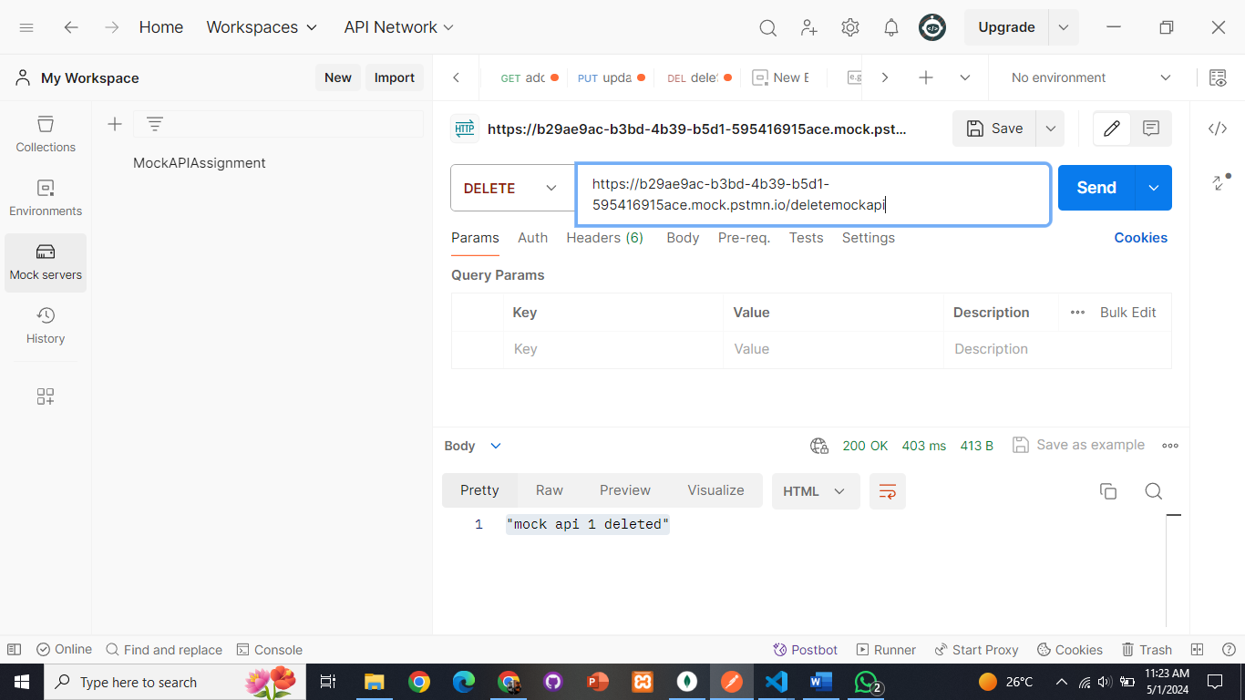

# API no 5:

**“Lock”-**Api:

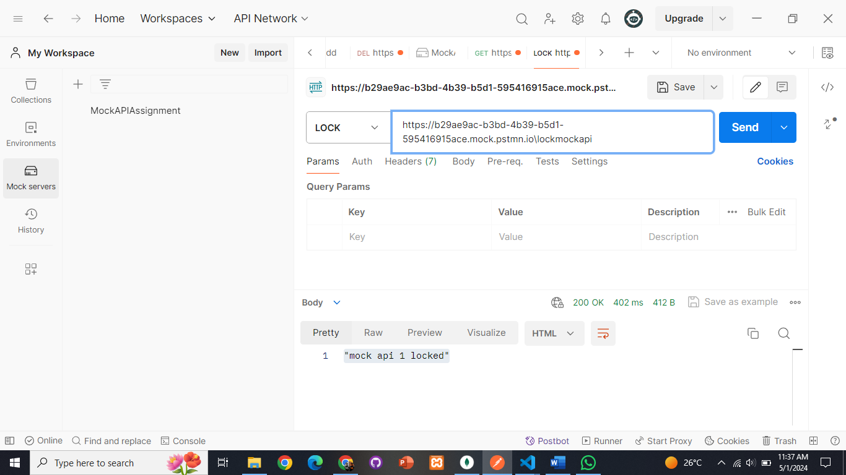

# API no 6:

**“Link”-**Api:

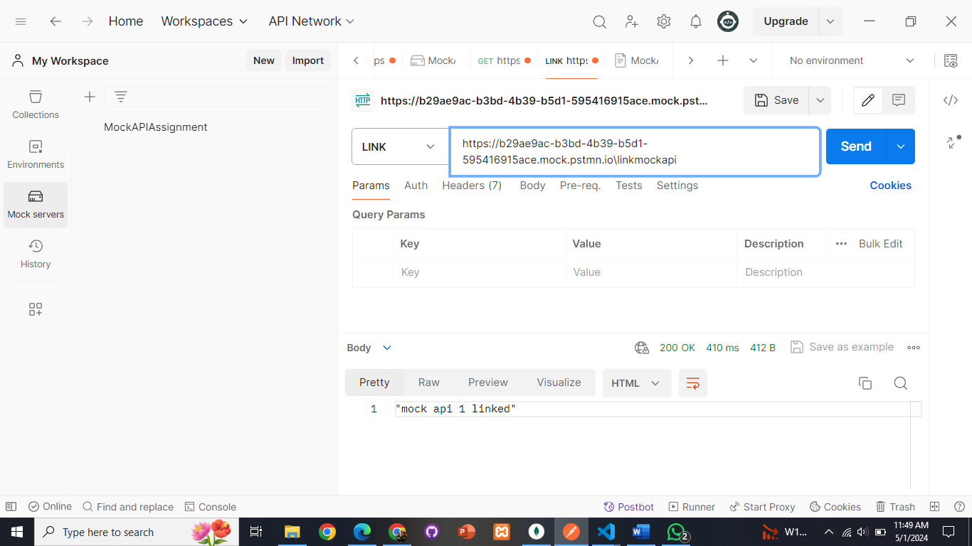

# API no 7:

**“UNLINK”-**Api:

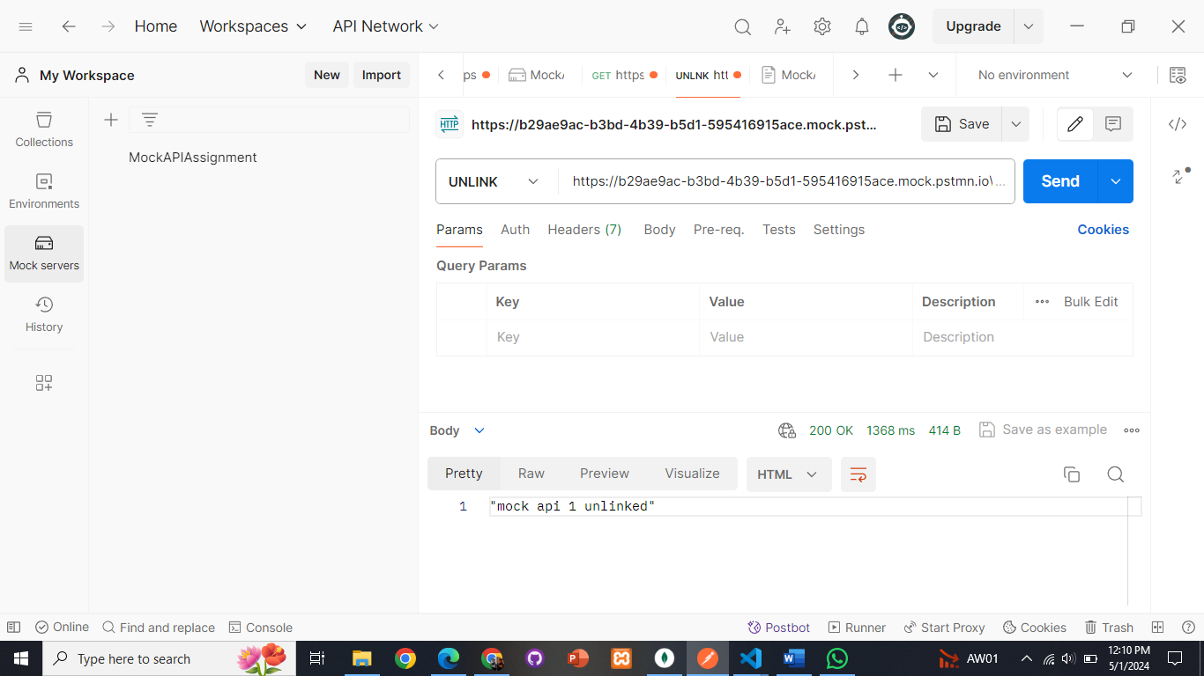

# API no 8:

**“COPY”-**Api:

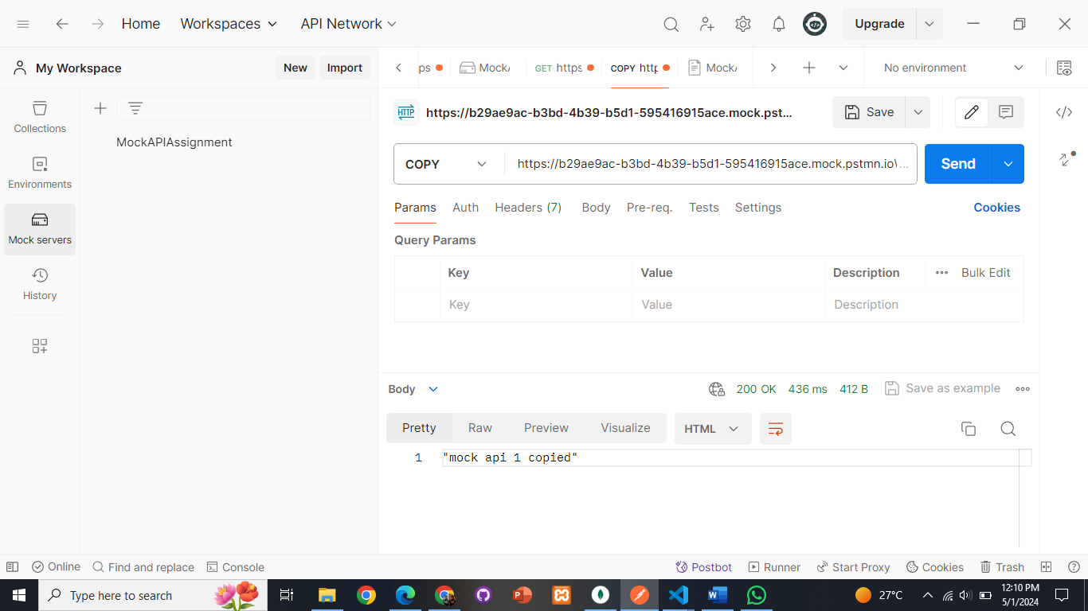

# API no 9:

**“Option”-**Api:

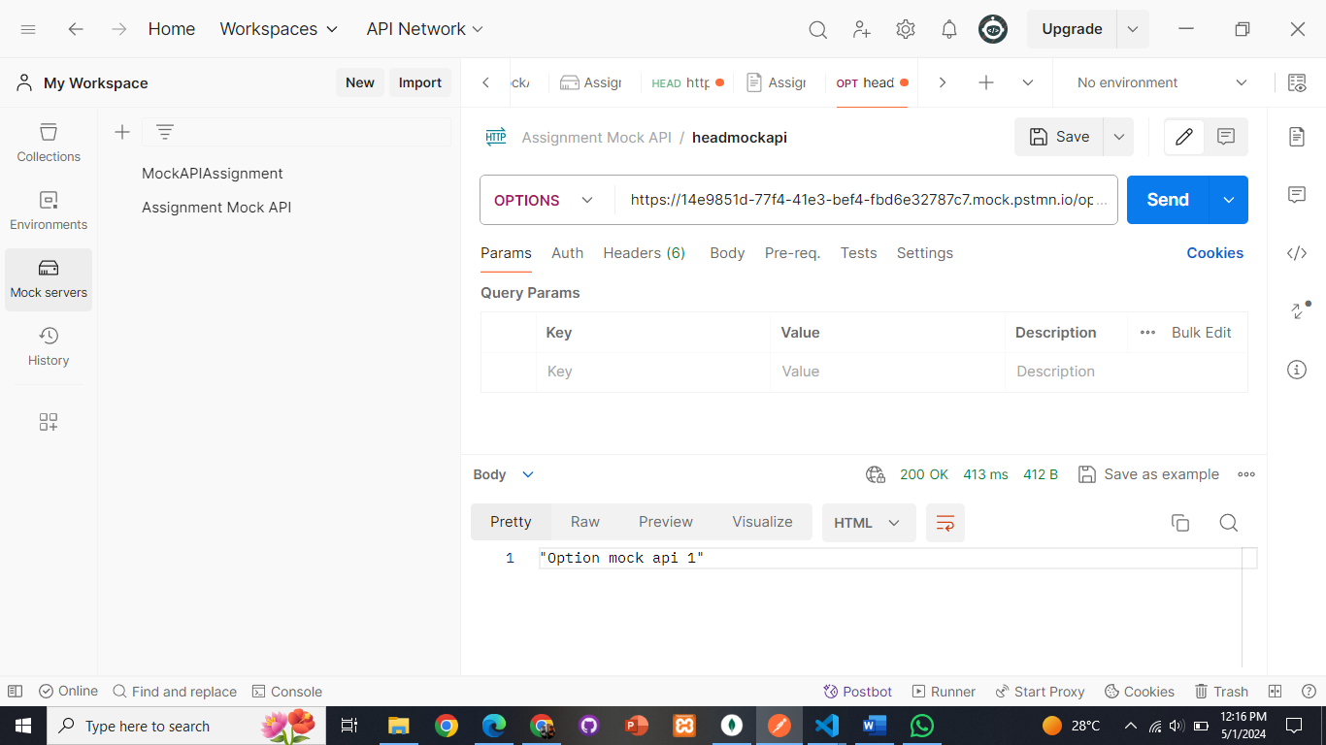

# API no 10:

**“Head”-**Api:

